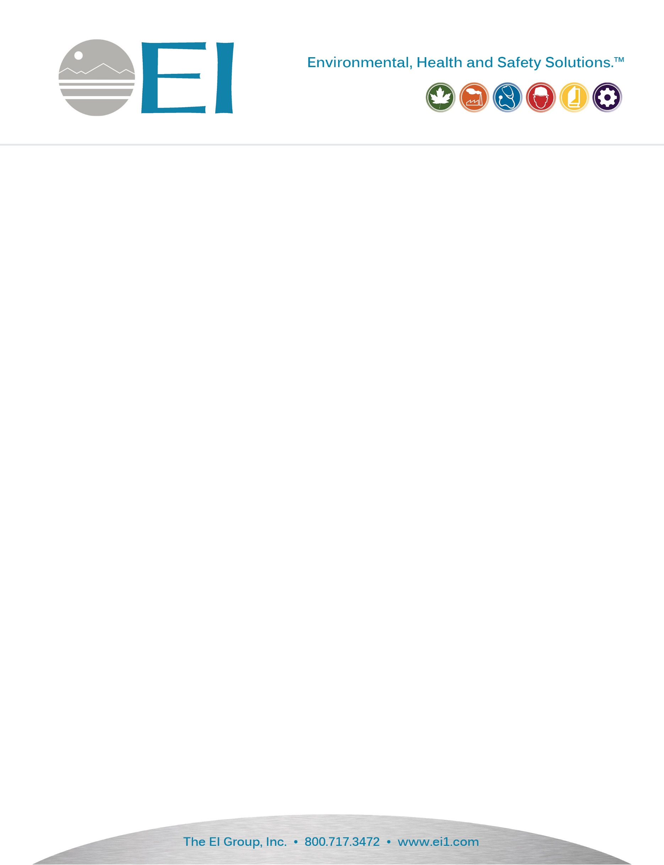

|  |
| --- |
| April 21, 2022    Dewberry Engineers, Inc. - ReBuild Phase 2  1545 Peachtree Street NE, Suite 250  Atlanta, Georgia 30309   RE: Asbestos Inspection390 Leanna Ln., Erwin, North Carolina 27886EI Project No: IHMO220064.00ReBuild NC Batch ID: APP-11349, INSP-0012665   Dear Mr. Ella Austin:    Per the contract outlined by The North Carolina Office of Recovery and Resiliency (NCORR), The EI Group, Inc. performed a limited asbestos inspection for the residence located at 390 Leanna Ln. in Erwin, North Carolina. The inspection was performed by Mr. Brian Long (NC Asbestos Inspector #13212) on April 08, 2022 and limited to the residence’s accessible interior and exterior. |

|  |
| --- |
| Methodology   *Asbestos Containing Materials (ACM)*    In order to complete the required ACM Survey, EI performed this survey in general accordance with 40 CFR 763 Subpart E.  The survey and sampling methods used as part of this survey are described below.    *ACM Visual Survey Methodology*    For the building structure a limited visual survey of building materials within the designated construction area was completed.  The purpose of this was for the certified inspection staff to identify the locations of all suspected ACM.  The inspector touched all suspected ACM to determine whether they are friable or non-friable materials.  Based upon the AHERA regulations, friable materials can be determined as those materials, that when dry, may be crumbled, pulverized, or reduced to powder by hand pressure, and includes non-friable materials that have become damaged to a point where they may also meet this determination.  This visual survey was also completed to identify all homogeneous areas of suspected ACM and to assess the physical condition of each of these materials.  A homogeneous area is defined as an area of surfacing material, thermal system insulation material, or miscellaneous material that is uniform in color and texture.  Once these homogeneous areas are established for the various inspected building, bulk samples were collected per the sampling methodology described below.    *ACM Sampling Methodology*    All sampling methods were collected in general accordance with NESHAP regulations.  Depending on the type of building materials, various sampling methodologies were employed and are described below.    Surfacing Materials  Surfacing materials are defined as material that is sprayed-on, troweled-on, or otherwise applied to surfaces, such as acoustical plaster on ceilings and fireproofing materials on structural members, or other materials on surfaces for acoustical, fireproofing, or other purposes.  All surfacing materials were collected with at least three (3) bulk samples by an accredited inspector in a statistically random manner that is representative of the previously identified homogeneous area.    Miscellaneous Materials  Miscellaneous materials are defined as building material on structural components, structural members or fixtures, such as floor and ceiling tiles, and does not include surfacing material or TSI.  All miscellaneous materials were collected by an accredited inspector in a manner sufficient to determine whether material is ACM or not ACM.  An accredited inspector collected bulk samples from each identified homogeneous area.    Thermal System Insulation  Thermal System Insulation (TSI) includes pipe insulation, boiler insulation, tank insulation, any insulation and other insulation needed for heating/cooling processes. At least three (3) samples of TSI were collected in a statistically random matter.    *ACM Analytical Methodology*  An appropriate number of samples, per the described methodology, were collected and submitted for analysis to Eurofins CEI, an NC NVLAP accredited laboratory.  Samples were analyzed by the Environmental Protection Agency (EPA) 600/R-93/116 Method using Polarized Light Microscopy.  Per the EPA if any homogenous material contains >1% asbestos by weight that material is considered asbestos containing and is therefore regulated.  A positive stop protocol was also employed. This directive to the lab stops analysis of samples at the first positive analysis of a homogeneous material group, eliminating multiple analyses of the same material.    EPA allows the drywall system components (wallboard, tape and joint compound) to be composited for analysis. See 40 CFR Part 61 (FRL-4821-7) “Asbestos NESHAP Clarification Regarding Analysis of Multi-layered Systems” as published on page 542 of the Federal Register Vol. 59, No. 3 dated January 8th, 1994.    Occupational Safety and Health Administrations (OSHA) considers any percentage of asbestos fiber in building material as a hazard and the building owner must ensure demolition contractor adhere all OSHA regulations regarding building materials containing asbestos fiber. |

|  |
| --- |
| Findings/Results   Suspect asbestos-containing materials that were visible/accessible within the residence consisted of the following: |

|  |
| --- |
| * 003 - Ceiling Tile * 002 - Gypsum Wallboard Joint Compound * 006 - Hard Plaster, Walls * 007 - Roofing, Composite Shingle * 004 - Tan Cork Floor * 005 - Tan Vinyl Floor * 001 - Textured Ceiling Material (Popcorn) * 008 - Window Glaze |

|  |
| --- |
| Of the suspected asbestos containing materials collected 3 types were found by analytical analysis to be regulated asbestos materials (>1% by weight). These materials are summarized below: |

|  |  |  |  |  |
| --- | --- | --- | --- | --- |
| Material | Location | Asbestos Amount | Condition | Approximate Quantity |
| 001 - Textured Ceiling Material (Popcorn) | Den | 2% Chrysotile (Serpentine group) | N/A | N/A |
| 001 - Textured Ceiling Material (Popcorn) | Living Room | 2% Chrysotile (Serpentine group) | N/A | N/A |
| 004 - Tan Cork Floor | Bathroom | 20% Chrysotile (Serpentine group) | N/A | N/A |
| 004 - Tan Cork Floor | Hallway | 20% Chrysotile (Serpentine group) | N/A | N/A |

|  |
| --- |
|  |

|  |
| --- |
| Conclusion/Recommendations   If the above identified materials containing >1 % asbestos are to be disturbed the owner must then adhere to all local, state and federal regulations regarding the removal and disposal of asbestos-containing materials (National Emission Standards for Hazardous Air Pollutants, Section 40 CFR Part 61.150). Any additional suspect materials identified outside of this survey should be presumed positive for ACM until further testing is completed.  Enclosed, please find copies of all chains of custody, laboratory analytical data, and licensure.  If you have any questions regarding this information, please feel free to contact me at your earliest convenience.    Sincerely,  The EI Group, Inc.    Text, letter  Description automatically generated    Ms. Kristen Switzer  Industrial Hygienist    Appendix A: Chain of Custody & Laboratory Analytical Data  Appendix B: Certifications & Licensure  Appendix C: Sample Location Maps  Appendix D: Photographs |

|  |
| --- |
| APPENDIX A: CHAIN OF CUSTODY AND LABORATORY ANALYTICAL DATA |

|  |
| --- |
|  |

|  |
| --- |
|  |

|  |
| --- |
| APPENDIX B: LICENSES AND CERTIFICATIONS |

|  |  |  |
| --- | --- | --- |
| |  |  | | --- | --- | | 13212, 09/30/2022, North Carolina, Brian Long |  | |

|  |
| --- |
| APPENDIX C: SAMPLE LOCATION MAPS |

**All Sample Locations for Main Floor**

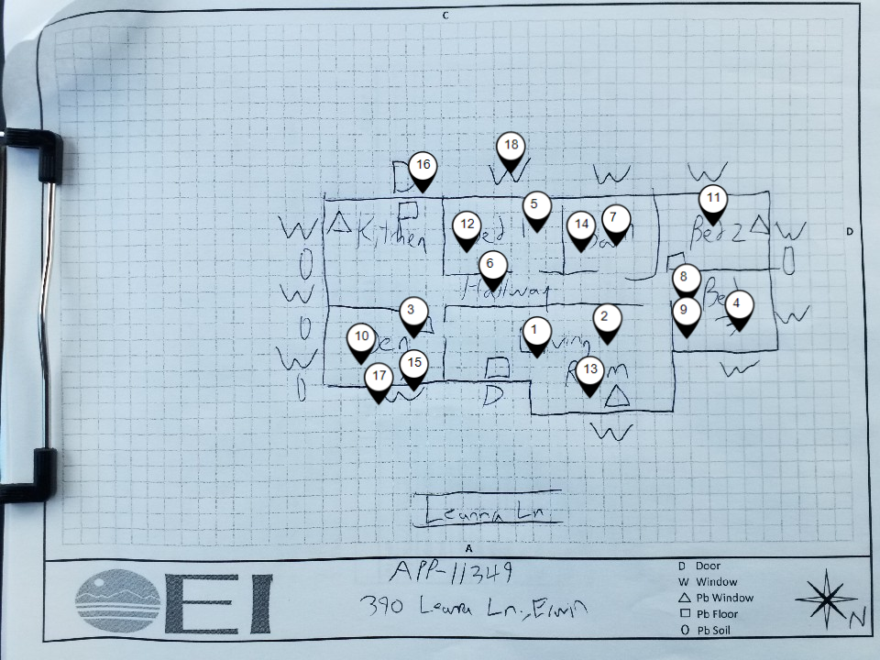

|  |  |  |  |  |  |
| --- | --- | --- | --- | --- | --- |
| Map ID | Sample ID | Space Name | Material | Lab Result | Analytical Result |
| 1 | 001A | Living Room | 001 - Textured Ceiling Material (Popcorn) | Greater Than 1% Asbestos by Lab (ACM) | 2% Chrysotile (Serpentine group) |
| 2 | 001B | Living Room | 001 - Textured Ceiling Material (Popcorn) | Greater Than 1% Asbestos by Lab (ACM) | 2% Chrysotile (Serpentine group) |
| 3 | 001C | Den | 001 - Textured Ceiling Material (Popcorn) | Greater Than 1% Asbestos by Lab (ACM) | 2% Chrysotile (Serpentine group) |
| 4 | 003A | Bedroom 3 | 003 - Ceiling Tile | Tested Negative by Lab (No Asbestos Detected) | N/A |
| 5 | 003B | Bedroom 1 | 003 - Ceiling Tile | Tested Negative by Lab (No Asbestos Detected) | N/A |
| 6 | 004A | Hallway | 004 - Tan Cork Floor | Greater Than 1% Asbestos by Lab (ACM) | 20% Chrysotile (Serpentine group) |
| 7 | 004B | Bathroom | 004 - Tan Cork Floor | Greater Than 1% Asbestos by Lab (ACM) | 20% Chrysotile (Serpentine group) |
| 8 | 005A | Bedroom 3 | 005 - Tan Vinyl Floor | Tested Negative by Lab (No Asbestos Detected) | N/A |
| 9 | 005B | Bedroom 3 | 005 - Tan Vinyl Floor | Tested Negative by Lab (No Asbestos Detected) | N/A |
| 10 | 002A | Den | 006 - Hard Plaster, Walls | Tested Negative by Lab (No Asbestos Detected) | N/A |
| 11 | 002E | Bedroom 2 | 006 - Hard Plaster, Walls | Tested Negative by Lab (No Asbestos Detected) | N/A |
| 12 | 002D | Bedroom 1 | 006 - Hard Plaster, Walls | Tested Negative by Lab (No Asbestos Detected) | N/A |
| 13 | 002C | Living Room | 006 - Hard Plaster, Walls | Tested Negative by Lab (No Asbestos Detected) | N/A |
| 14 | 002B | Bathroom | 006 - Hard Plaster, Walls | Tested Negative by Lab (No Asbestos Detected) | N/A |
| 15 | 007A | Exterior | 007 - Roofing, Composite Shingle | Tested Negative by Lab (No Asbestos Detected) | N/A |
| 16 | 007B | Exterior | 007 - Roofing, Composite Shingle | Tested Negative by Lab (No Asbestos Detected) | N/A |
| 17 | 008A | Exterior | 008 - Window Glaze | Tested Negative by Lab (No Asbestos Detected) | N/A |
| 18 | 008B | Exterior | 008 - Window Glaze | Tested Negative by Lab (No Asbestos Detected) | N/A |

|  |
| --- |
| APPENDIX D: PHOTOGRAPHS   **Asbestos-Containing Material (Tested Greater Than 1%) Photographs** |

|  |  |  |  |  |
| --- | --- | --- | --- | --- |
| |  |  | | --- | --- | | 001A, 001 - Textured Ceiling Material (Popcorn), Living Room | 001C, 001 - Textured Ceiling Material (Popcorn), Den | | 004A, 004 - Tan Cork Floor, Hallway | 004B, 004 - Tan Cork Floor, Bathroom | |

|  |
| --- |
| **Asbestos-Containing Material (Assumed Positive) Photographs** |

|  |
| --- |
| No images found for homogenous materials that are assumed positive containing asbestos |

|  |
| --- |
| **Trace Positive Material (Equal to or Less Than 1% Asbestos) Photographs** |

|  |
| --- |
| No images found for samples that have tested positive containing less than or equal to 1% asbestos. |

|  |
| --- |
| **Materials That Tested Negative for Asbestos Photographs** |

|  |  |  |  |  |  |  |
| --- | --- | --- | --- | --- | --- | --- |
| |  |  | | --- | --- | | 002A, 006 - Hard Plaster, Walls, Den | 002D, 006 - Hard Plaster, Walls, Bedroom 1 | | 003A, 003 - Ceiling Tile, Bedroom 3 | 005A, 005 - Tan Vinyl Floor, Bedroom 3 | | 007A, 007 - Roofing, Composite Shingle, Exterior | 008A, 008 - Window Glaze, Exterior | |

|  |
| --- |
| **Elevation Photos** |

|  |  |  |  |  |  |  |  |  |  |  |
| --- | --- | --- | --- | --- | --- | --- | --- | --- | --- | --- |
| |  |  | | --- | --- | | Side A | Side B | | Side C | Side D | | Den | Living Room | | Bedroom 3 | Bedroom 2 | | Bathroom | Bedroom 1 | |